

**Lab Report -3**

**Course code: CSE2104**

**Course title: Object Oriented Programming Lab**

**Submitted by:**

**Sakib Mahmud Dipto**

**Submitted to:**

**Name:Mahfuzur Rahman**

**ID: 193014011**

**Date of experiment: 23/06/24**

**Date of submission: 7/01/24**

1. Here's a Python program that checks if a user integer is a palindrome:

import java.util.Scanner;

public class PalindromeChecker {

public static void main(String[] args) {

Scanner scanner = new Scanner(System.in);

System.out.print("Enter an integer: ");

int number = scanner.nextInt();

if (isPalindrome(number)) {

System.out.println(number + " is a palindrome.");

} else {

System.out.println(number + " is not a palindrome.");

}

scanner.close();

}

public static boolean isPalindrome(int number) {

if (number < 0) {

return false;

}

int originalNumber = number;

int reversedNumber = 0;

while (number != 0) {

int digit = number % 10;

reversedNumber = reversedNumber * 10 + digit;

number /= 10;

}

return originalNumber == reversedNumber;

}

}

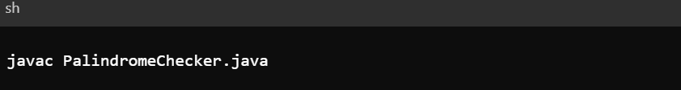

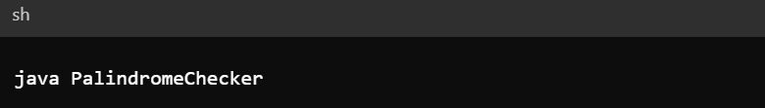

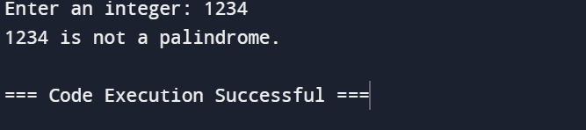

The code defines a function called is palindrome that converts an integer to a string, reverses the string, and compares the original string with the reversed string. It prompts the user for an integer input, checks if it's a palindrome, and prints the result.

2. Take a string input from user and reverse it

Here's a Python code that takes a string input from the user and reverses it:

import java.util.Scanner;

public class ReverseString {

public static void main(String[] args) {

Scanner scanner = new Scanner(System.in);

System.out.print("Enter a string: ");

String userInput = scanner.nextLine();

String reversedString = new StringBuilder(userInput).reverse().toString();

System.out.println("Reversed string: " + reversedString);

scanner.close();

}

}

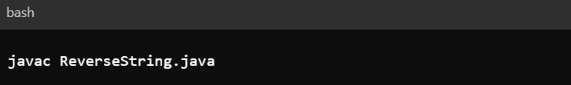

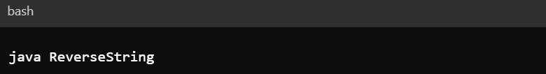

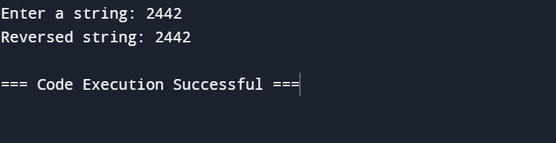

This code defines a function reverse_string that takes a string as input and returns the reversed string. The function uses slicing syntax s[::-1] to achieve this. Slicing with a step of -1 iterates through the string in reverse order.

Here's how the code works:

The reverse string function is defined, requiring a string s as input and returning the reversed string. The code prompts the user to enter a string, stores it in the variable user input, calls the reverse string function, and prints the reversed string to the console.

Reference

(<http://python-reference.readthedocs.io/en/latest/docs/brackets/slicing.html>)

(<https://docs.python.org/3/library/string.html>)

Github: